SchreenShoot Hasil Latihan Praktikum 5

*Praktikum Citra Digital*

Nama : Shifa Mutia Fauziah

NIM : 1207070114

Kelas : TKK

## Brightness, Contrass, Autolevel Contrass

* Brightness Grayscale

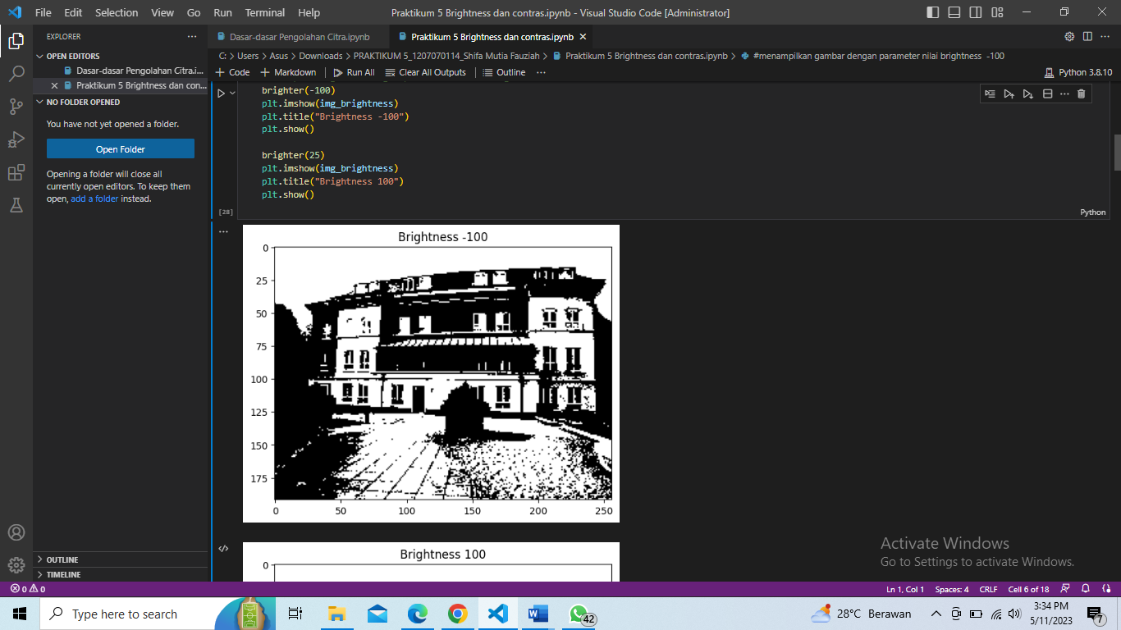

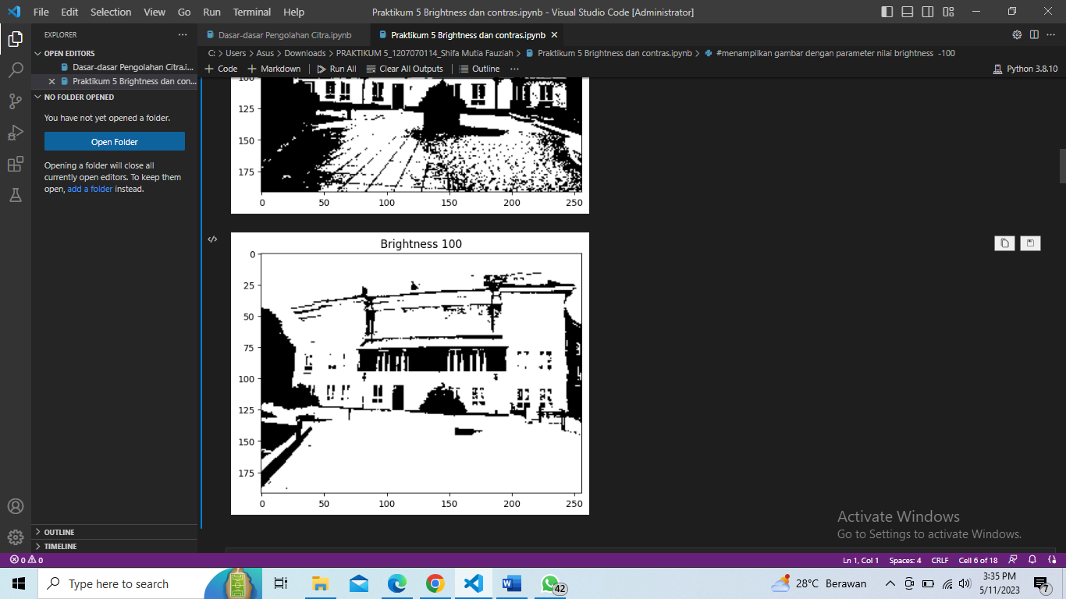

## Brightness RGB

## 

## 

## Contrass

## 

## 

## RGB Contrass

## 

## 

## Contrast Autolevel

## 

1. **Dasar-Dasar Pengolahan Citra**

* Cropping Image

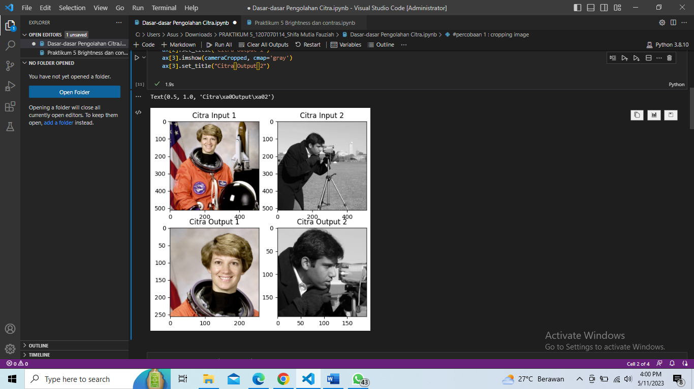

* Citra Negative

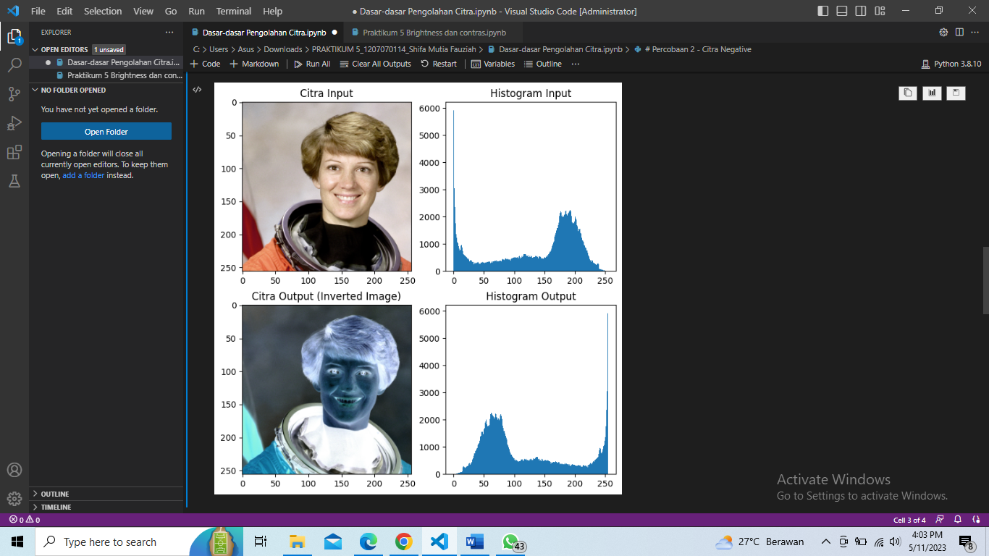

* Increase Brightness

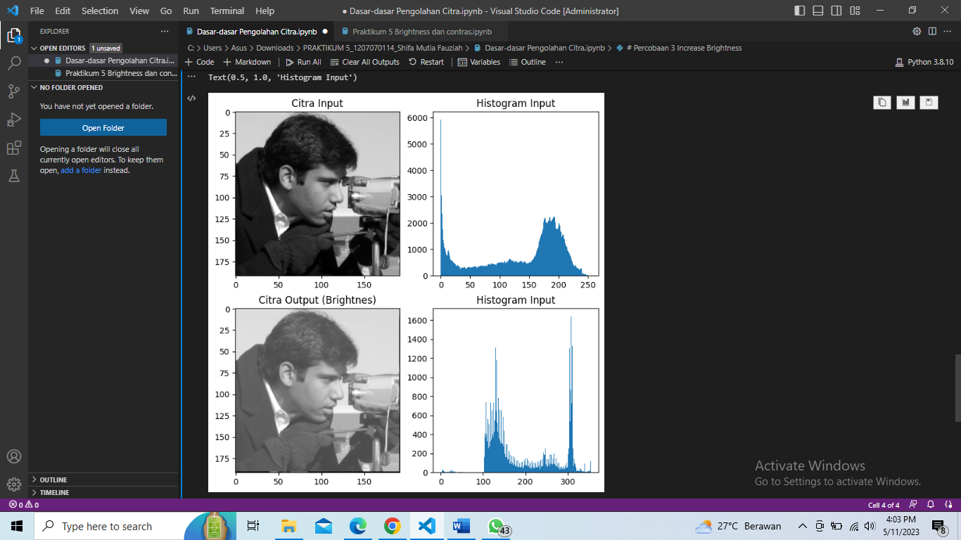

* Gambar Sendiri

1. Cropping Image

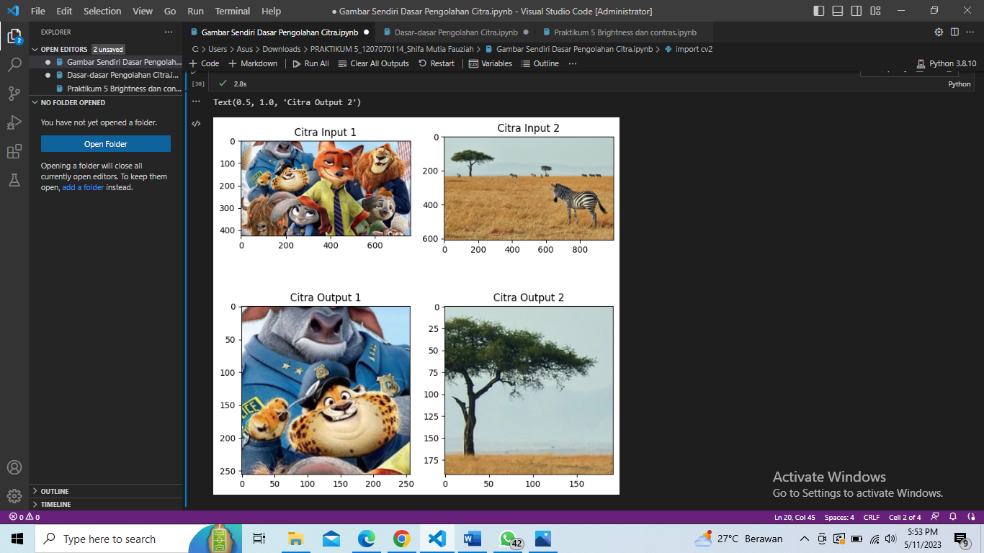

1. Citra Negative

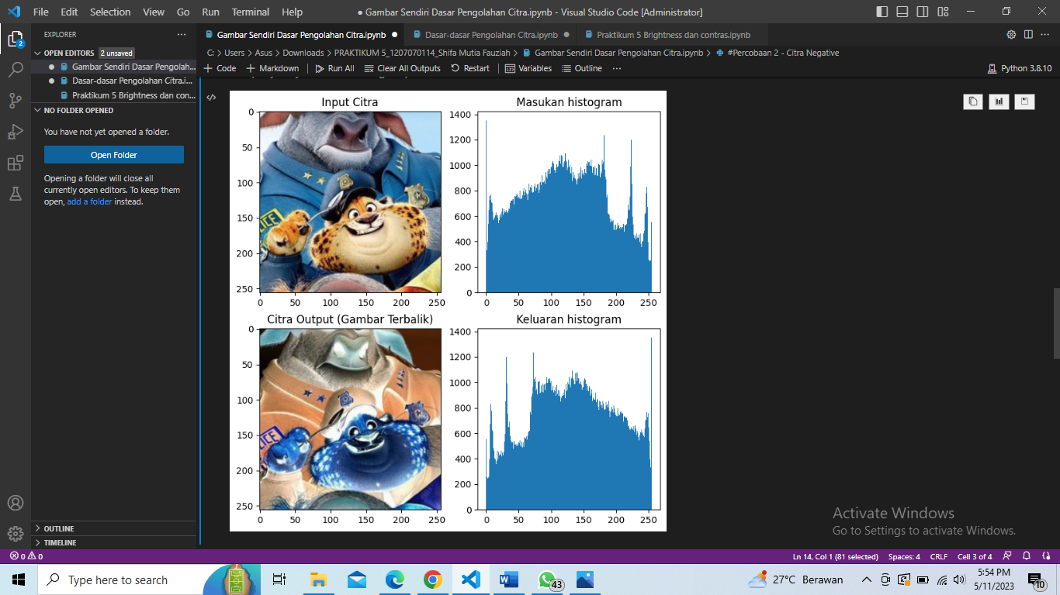

1. Increase Brightness

